10/15/2024

Khairul Islam

Wealth of Nations

Data Project

Assignment 1 Data Visualization

Contents

**Assignment Requirements**

• Cover page ............................................................................................................ 1

• Table of Contents ............................................................................................................. 2

• Main body .................................................................................................................... 2

• A reflective .............................................................................................................. 2

***Assignment 1 Data Story Telling ..................................................................... 3***

**Scenario** .............................................................................................................................. 3

**First Task** ............................................................................................................. 3

**Policies and Procedures ................................................................................................... 3**

**Second task**............................................................................................................. 4

**Excel** ...................................................................................................................................... 4

**The data** ................................................................................................................................. 4

**Third Task** ........................................................................................................................... 19

**Tableau**...................................................................................................................................19

**Data visualization**……………………………………………………………………………………………………….20

**Dashboard screenshots**……………………………………………………………………………23

**Link to dashboard**…………………………………………………………………………….26

**Policies and Procedures**

When working with data there are a bunch or rules we should follow.

1. Data privacy policies

These polices include data protection laws which maintain the collection, use and storage of personal data. User rights which give the person access to change or delete personal data. Informed consent where the person knows what their data collection will be used for and why.

1. Data security polices

These polices are there to protect the persons data from being accessed by someone unauthorised. A few examples are Data encryption, Multi factor authentication and access control.

1. Ethical data use

Ensure that the data being used is fair and unbiased. Telling them how they’re data is going to be used and collected.

**Excel Work**

1. Set a password to protect the workbook

So, to set a password first we need to click on the file tab on the top left and it will open a new screen.

Once that screen opens, we click on the info button and you should see the protect workbook feature, press that then select encrypt with password and set your password.

1. Highlight column c and change the data to display in British pounds

To highlight the column double click the C column which we are going to be changing.

To change the currency, we need to open the home tab and navigate to the Number section and there you will find a symbol to change it. Press it then change it from dollars to pounds.

1. Turn the GDP sheet into a table

To turn the sheet into a table, navigate to the insert tab then click Table and it will allow you to enter the data you want in it. Here we typed $A$1:D$229 which is the range of data that is going in the table and pressed ok.

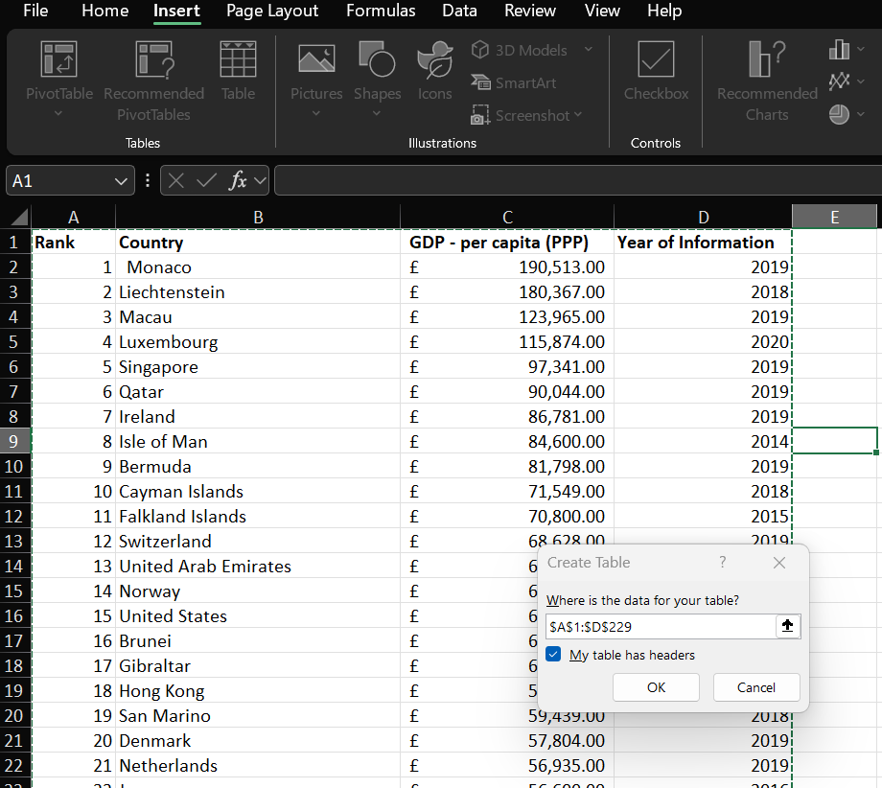

1. Filter the data to show only the information for 2019

To filter the year of the table we need to press the drop-down box where it says year of information. Once we click that we uncheck all the boxes but 2019.

1. Create a chart that will display Rank country and GDP

So, to create a chart first we need to select the data in which we want in the chart. Click on the insert tab and navigate to the chart section and select a suitable chart for the data.

1. Add a title, x and y axis and make the chart visually pleasing.

To change the title, click on the chart and 3 boxes will pop up chart style and chart elements and chart filters. To change the title and axis use the chart elements box and to change the colours and look click on the chart styles box.

1. Move the chart to a new sheet and label with a suitable name.

At the bottom of the screen, you will find the sheets press the + to add a new sheet then copy and paste the chart from the Main sheet to the new sheet. To rename it double click the sheet tab and it will allow you to change the name.

1. Create a sort for the top 20 highest ranking country from your sort.

To sort the data, you need to go to the data ribbon select the sort button then change the range of values you want in this case we would do for the top 20 countries. Here we used a different method to get the top 20 countries. First, we need to type in a formula. The formula we type is =Take (A2:C229,31) which will select the range of cells in the brackets up to row 31 from our main table. This will make a new table and give us only those cells in this case will give use the top 20 highest ranking countries in 2019.

1. Create a new bar chart to display the top 20 countries and move the chart underneath the sort.

To create the new bar chart, we highlighted all the data we want. Then click on the insert tab and find charts. After that selected the bar chart we want and placed it next to the sort.

1. Colour the background by highlighting the area underneath the table.

Here we changed the colour of the table by pressing the chart then selecting the home tab and filling it with the paint icon under fonts.

**Adding Macros**

1. **Create 3 macro buttons**

To add the macros ribbon we need to go to file then select options. Once the options menu opens, we need to click the customize ribbon button then scroll to where you see developer and select ok.

After that we added 3 macro buttons which we used the insert control under developer Print, save and copy.

To make a copy macro, highlight the area you want to copy then stop recording the macro. After that assign it to the copy button.

1. Assigning the macro to a new word document

When we click the copy macro button on excel it will allow us to copy the data to a new sheet once we paste it. Here it is on Microsoft word.

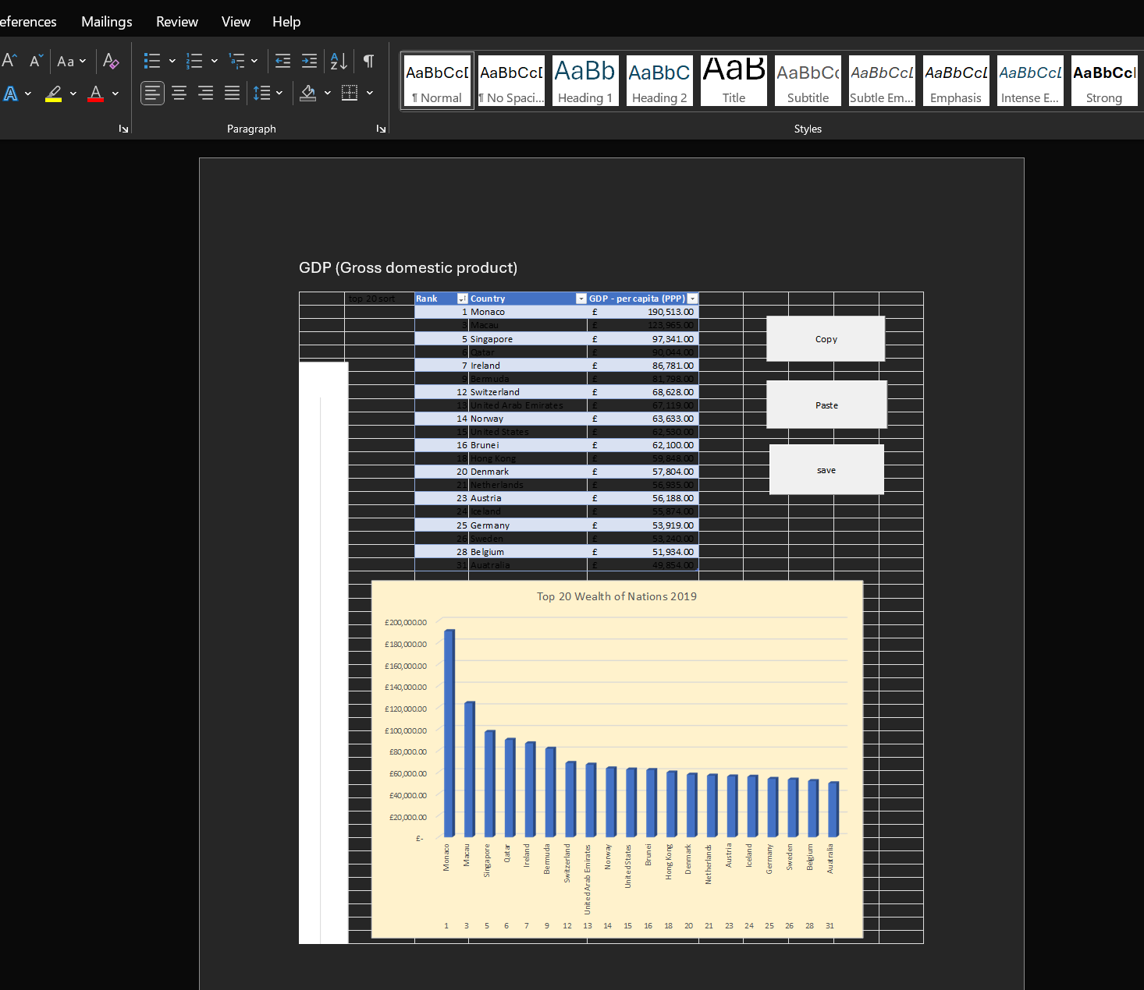

1. Save the document as `word gross domestic product report 1`

1. Add a header and footer to our table

Select the insert tab and find headers and footers then select it. After that change the names to something suitable.

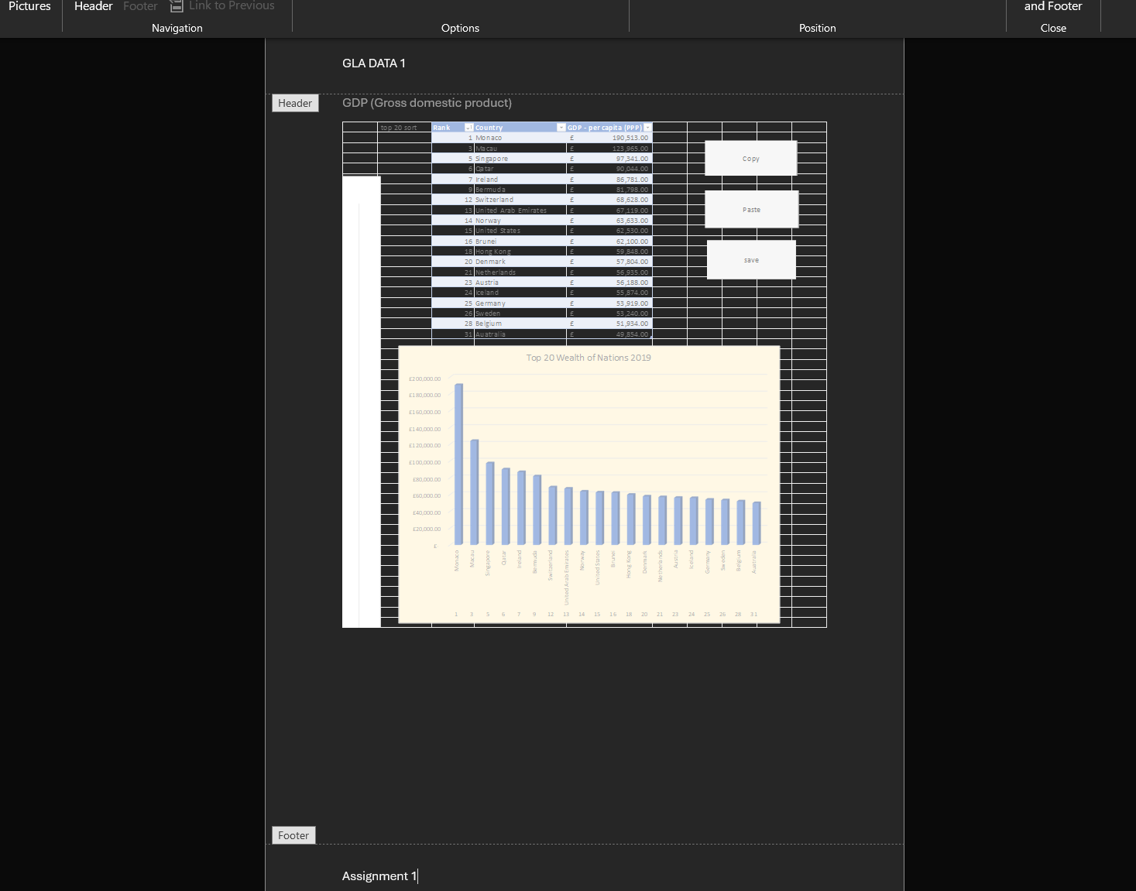

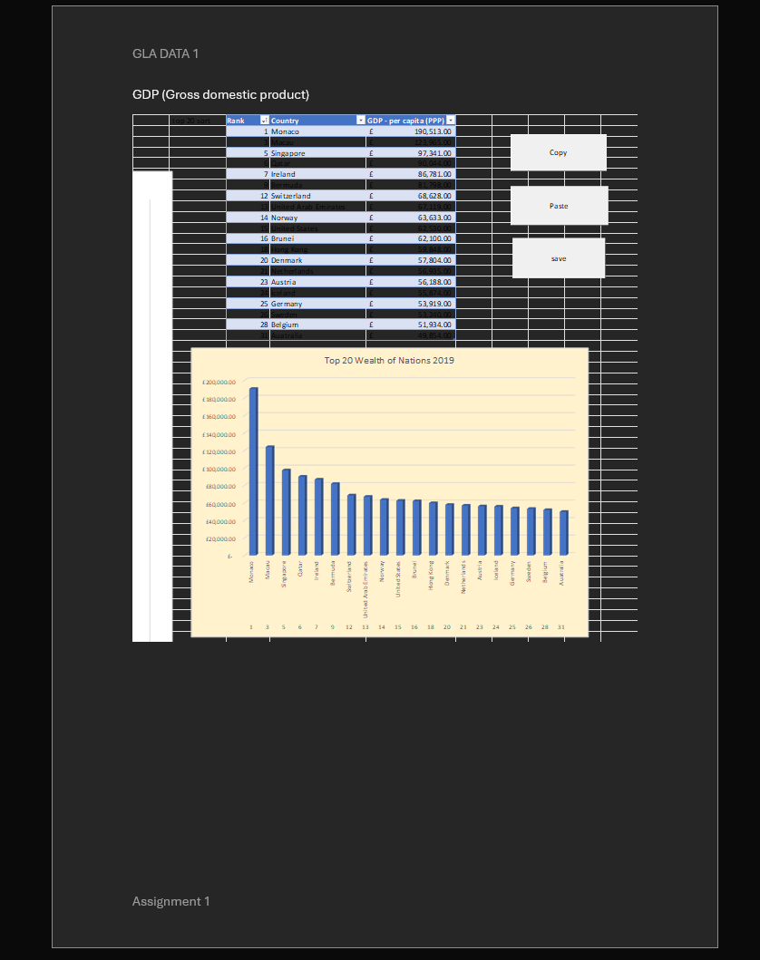

Final Product of the top 20 countries in 2019.

Task 3 Tableau

Importing data

So here we need to import the data from the wealth of nations excel file to tableau. To do this under where it says connect click on Microsoft excel then choose the file we want to use and open it.

Set relationship

The relationship is used to blend the different data sets from different sheets into one. To do this, we drag all the different sheets into the page and link them with something they all have in common. In the wealth of nations file they all have country in common, so we select this relationship and continue.

**Creating 4 graphs for visualizations**

Client requirement

* Colourblind
* Top 20 countries

Here we are filtering the table to only have the top 20 countries. To do this we drop the countries to the filter box and pick the countries we want.

Graph 1

This shows the top 20 countries with the highest all time GDP

Here I added countries GDP and rank to the label section. I filtered countries to show the top 20 only. I then changed the map design to satellite view and the colour to orange.

Graph 2

My next Graph will show the top 20 country smartphone users and how many users there are.

I moved countries for smartphones to the colour and labels section. I then moved the total smartphone users and ranking to label. I changed the map design from light to normal to add a little more contrast.

Graph 3

The next graph will show the life expectancy of the top 20 countries.

I started by creating a bar chart by moving life expectancy to columns and country to rows. I then added the life expectancy to label and countries to colour.

Graph 4

This graph shows the GPD for the top 20 countries in a table

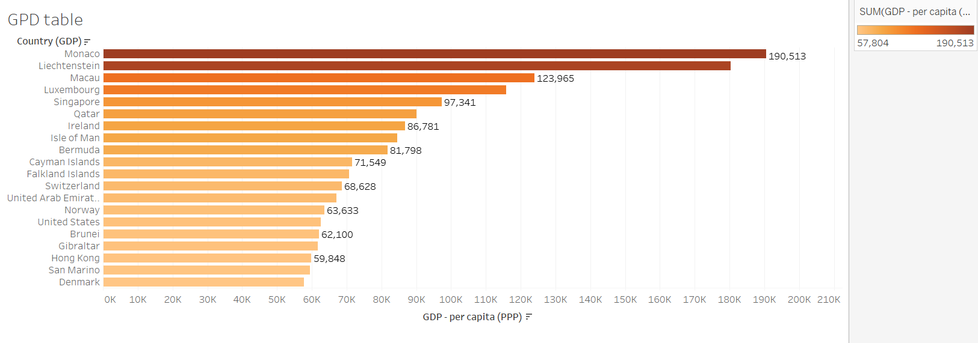

I moved the GPD per capita to the columns and country to rows. I then filtered it out to only show the top 20 countries in descending order. After that I moved the GPD to label and changed the colour to orange, so it is more visually pleasing and suitable.

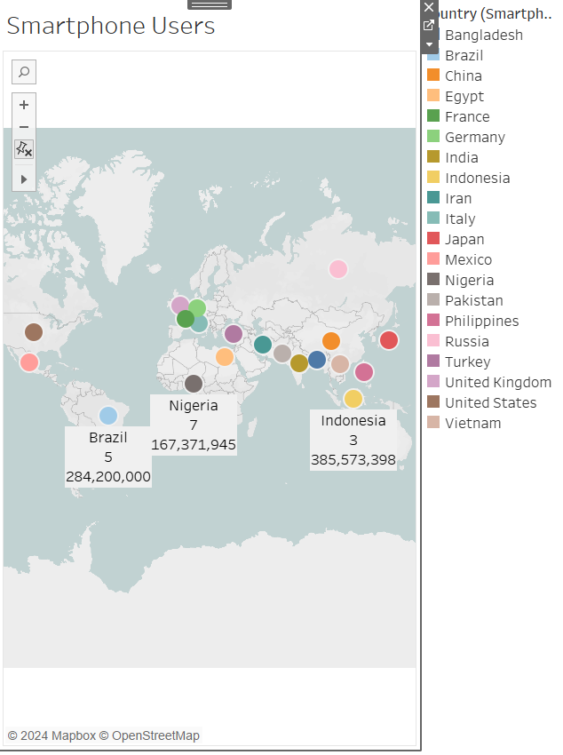

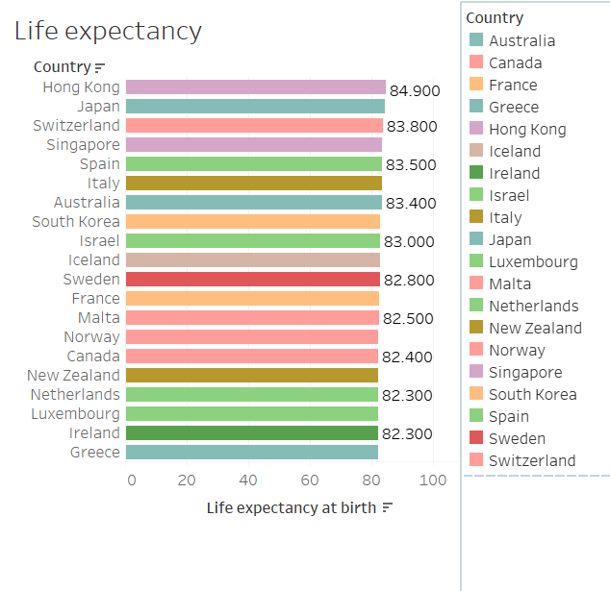

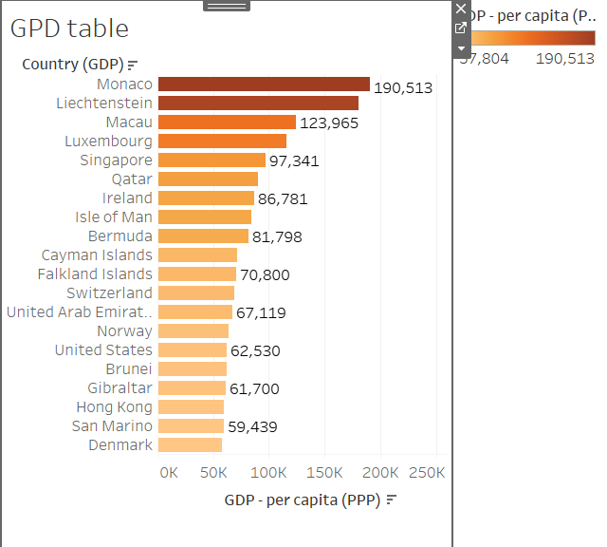

Link to dashboards

<https://public.tableau.com/views/DashboardsDataAssignment/GPDtable?:language=en-GB&:sid=&:redirect=auth&:display_count=n&:origin=viz_share_link>